Week 1

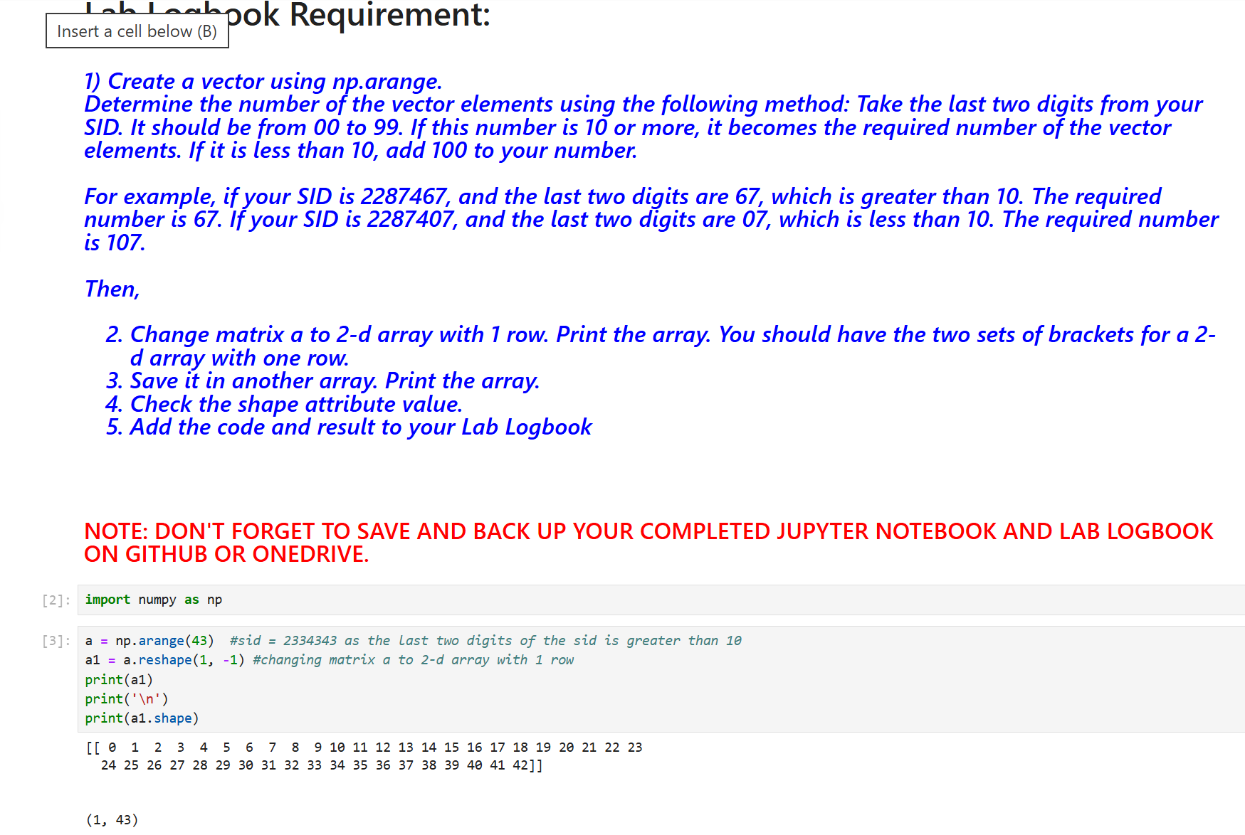

Week 2

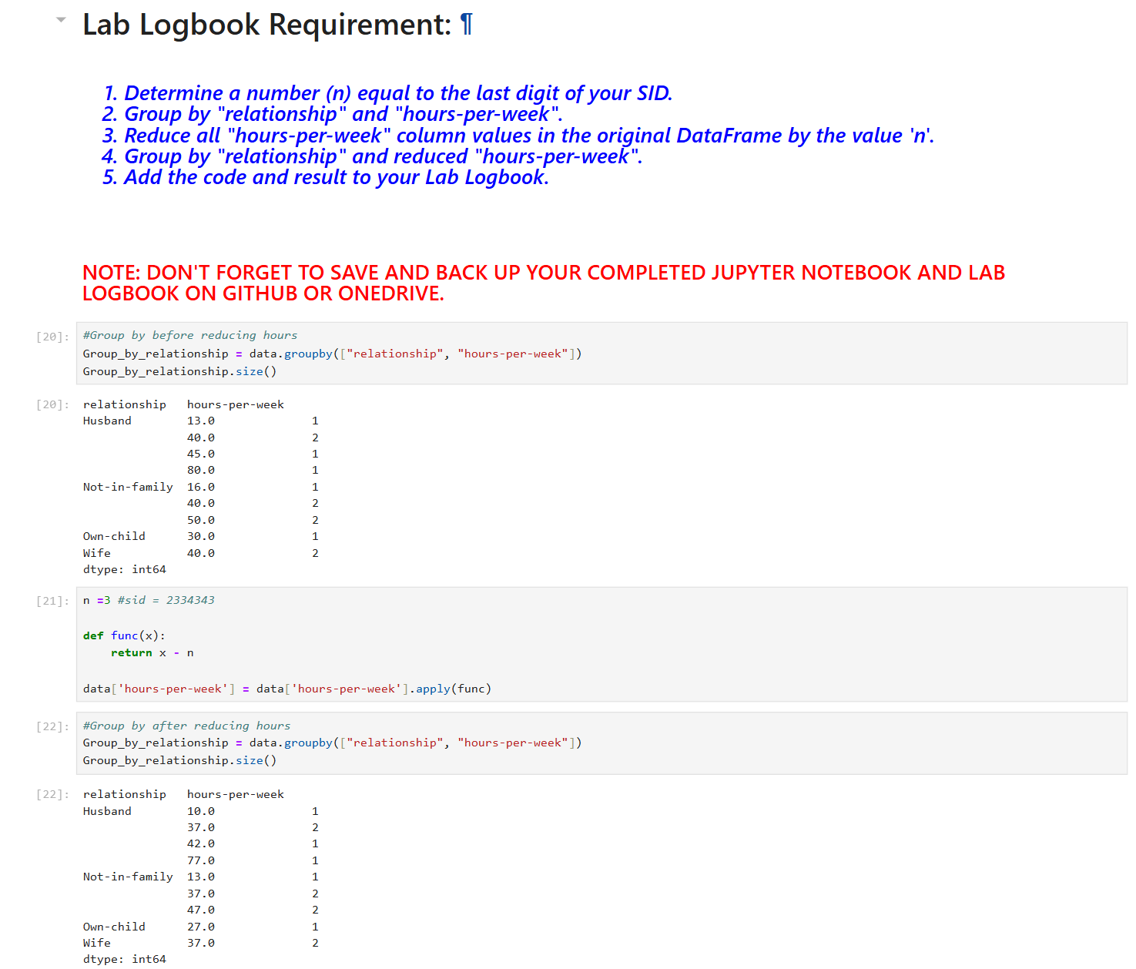

Week 3

Week 5

Week 7

Week 10

Week 11

